Instructions

Drive link - <https://drive.google.com/file/d/1Vr2YrvRSanKGdhsm6lmTNOTbq8Xwk8uD/view?usp=sharing>

1. Download and install anaconda3 from given link

- link : <https://www.filehorse.com/download-anaconda-64/download/>

- At the stage given in the image below check both checkboxes

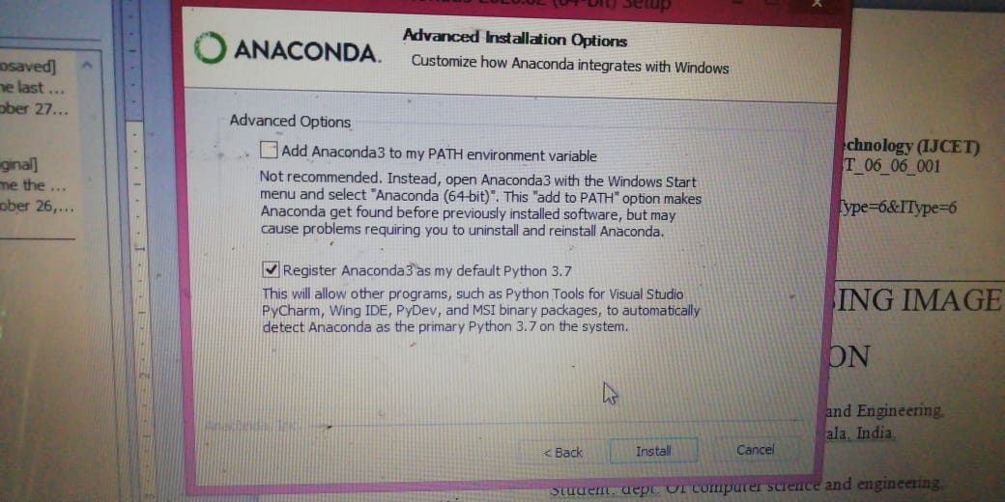

1. Open anaconda prompt
2. In prompt(cd) Navigate to project folder
3. Run command : pip install opencv-python
4. Run command : pip install numpy
5. Run command : python fusedImage.py

Dataset info : https://cvit.iiit.ac.in/projects/mip/drishti-gs/mip-dataset2/Home.php